**Assignment – 4**

**Retrieving Information from Tables**.

1. Write a select command that produces the order number, amount, and date for all rows in the Orders table.

mysql> select Onum, Amt, Odate

-> from Orders;

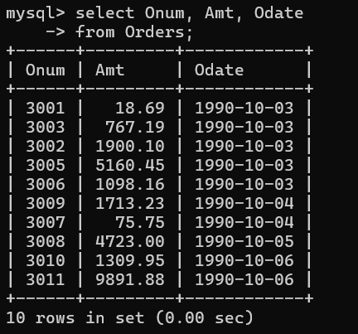

1. Write a query that produces all rows from the Customers table for which the salesperson’s number is 1001.

mysql> select *from customers

-> where Snum = 1001;

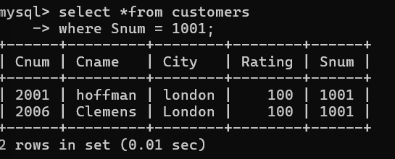

1. Write a query that displays the Salespeople table with the columns in the following order: city, sname, snum, comm.

mysql> select City, Sname, Snum, Comm

-> from Salespeople;

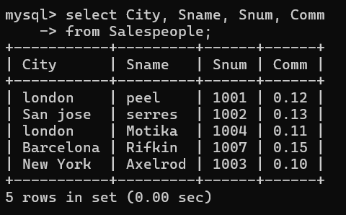

1. Write a select command that produces the rating followed by the name of each customer in San Jose.

mysql> select Rating , Cname

-> from Customers

-> where City = 'san jose';

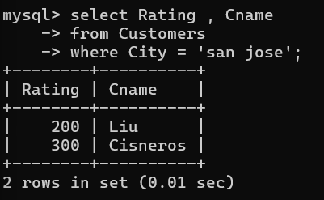

1. Write a query that will produce the snum values of all salespeople (suppress the duplicates) with orders in the Orders table.

mysql> select distinct Snum

-> from orders;

